Product Specifications

Table of Contents

Modification History 2
Major Milestones 3
Abstract 4
Document References 5
Glossary 6
Use Case Sequence Diagram 7
Use case 1(Register New Account ) 7
Use case 2(Log in) 8
Use case 3(Play as Guest) 9
Use case 4(Reset Password) 10
Use case 5(Display Player Statistics) 11
Use case 6(Player vs. Player) 12
Use case 7(Player vs. AI) 12
Use case 8(Difficulty Level) 14
Use case 9(Select Tile) 15
Use case 10(Select First Player) 17
Use case 11(Exit) 18
Use case 12(Taken Username) 18
Use case 13(Incorrect Log in information) 20
Use case 14(Forgotten Username) 21
Use case 15 (Incorrect Answer to Security Question) 22
Use case 16 (Statistics for New User) 23
User Interface 24
Design Documentation 25
Finite State Machine Diagrams 25
Class Diagram 33
Pseudo Codes 33
Pseudo Code for ResetPassword.cpp 33
Pseudo Code for selectgamemode.cpp 35
Pseudo Code for gamemode.cpp 36
Pseudo code for aiclass.cpp 38
Pseudo code for gameboard.cpp 54
Pseudo code for gameboard.cpp 58
Pseudo code for difficultylevel.cpp 60
Pseudo Code for registrationScene.cpp 63
Pseudo Code for gameoption.cpp 64
Pseudo Code for maintictactoe.cpp 65
Pseudo Code for Main.cpp 66
Pseudo Code for LoginScene.cpp 67
Test Cases 68
Non-functional and Functional testing 71
Functional Testing 78

Modification History

Item | Date | Changes | Comments
1. | 2/26/2016 | - Use Case Diagram modified to accommodate guest user specifications and history record.
2. | 2/26/2016 | - Edited for consistency and clarity
3. | 4/1/2016 | - Modified use case scenarios and added all exception scenarios.  - Created all state diagrams for entity classes and UI
3. | 4/1/2016 | - Modified the documentation for testing and improving plans on development. These test faces included non-functional and functional tests
4. | 4/13/2016 | - Added missing sequence diagrams into the pseudo code category Pseudo code for gamemode, gameboard, playergameoptions, difficultylevel
4. | 4/13/2016 | - Created a class AI
4. | 4/13/2016 | - Modified the pseudo code maintictactoe.cpp to construct a QMainWindow with given parent and create instances of widgets as described in ui file.

Major Milestones

Date | Milestone
02/01 | Software management plan
02/15 | Complete software management plan
03/02 | Specification plan
03/11 | Complete specification plan
03/20 | Requirement
03/27 | Complete requirement
04/01 | Testing
04/09 | Complete Testing

Abstract
Tic-Tac-Toe is a two-player game, played on a 3x3 grid, where the winner is the first player to connect three in a row. Despite its simplicity, it is a good exercise for improve reasoning skills. Due to this, it is considered a good game for children to help them improve their acumen. The game was originally played on paper, and was one of the first games played on a computer. The purpose of this project is to develop a new version of the game utilizing a 6x6 grid in which the winner is determined when the board is completely full. The winner is actually the player with the most 4 in a row squares.

Document References
Document | Location
Requirements | GitHub
Software Management Plan | GitHub
Specifications | GitHub
Minutes and Time Log | GitHub

Glossary

Term | Definition
Graphical User Interface | A graphical user interface is a human-computer interface (i.e., a way for humans to interact with computers) that uses windows, icons and menus and which can be manipulated by a mouse (and often to a limited extent by a keyboard as well).
6x6x4 grid | A grid with 6 boxes on each side (6x6), consisting of 36 total units. The winner is the player with the most 4 stones(x4) in a horizontal, vertical, or diagonal row.
Tic tac toe | A game for two players who take turns marking the spaces in a grid. The player who succeeds in placing three respective marks in a horizontal, vertical, or diagonal row wins the game.
Single Player | A single-player video game is a video game where input from only one player is expected throughout the course of the gaming session. "Single-player game" usually refers to a game that can only be played by one person, while "single-player mode" usually refers to a particular game mode that is designed to be played by a single player, though the game also contains modes that can be played by several players simultaneously.
Multi-player | A multi-player video game is a video game in which more than one person can play in the same game environment at the same time. Computer and video games are often single-player activities that put the player against pre-programmed challenges and/or AI-controlled opponents, which often lack the flexibility and ingenuity of regular human thinking.
User | A user is an agent, either a human agent (end-user) or software agent, who uses a computer or network service. A user often has a user account and is identified by a username (also user name). Other terms for username include login name, screen name (also screenname), nickname, or handle
Password | A password is a secret word or string of characters that is used for user authentication to prove identity, or for access approval to gain access to a resource.

Acronym | Meaning
GUI | Graphical User Interface
AI | Artificial Intelligence

Use Case Sequence Diagram

Use case 1(Register New Account )
General Description
The Register New Account use case enables a user/actor to add his/her information to a database in order to create a new account. The information requested includes first name, last name, username, security question/answer and password.
Sequence Diagram
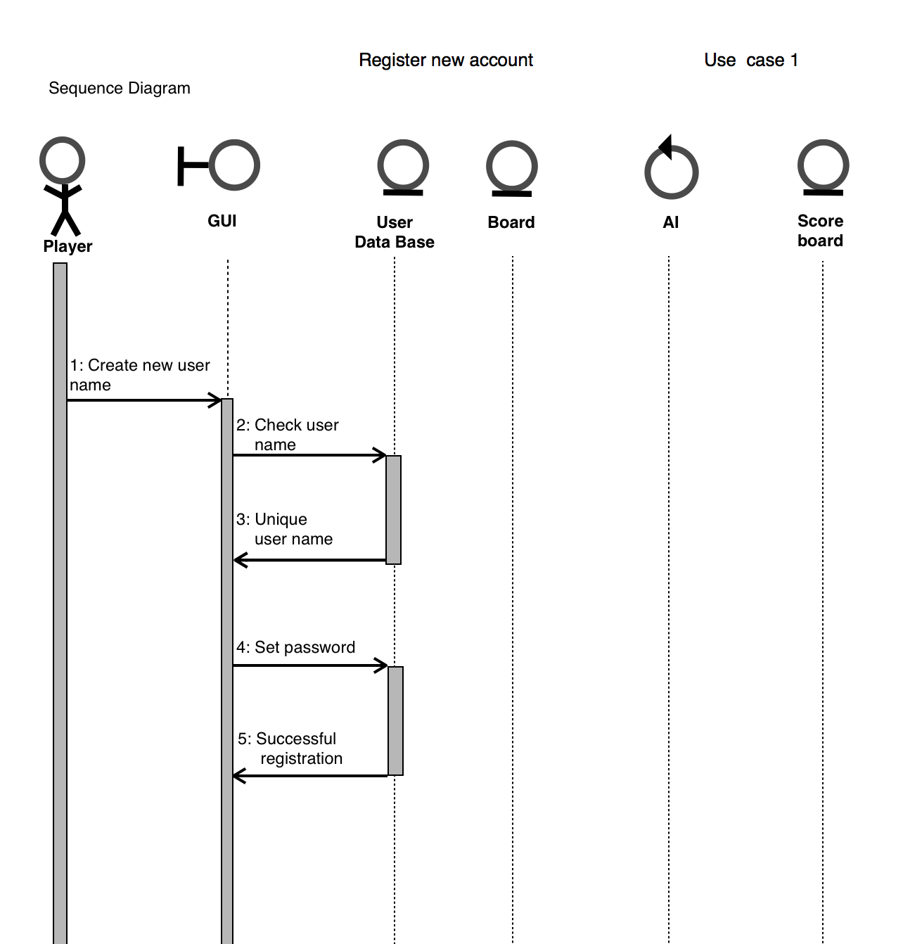

Use case 2(Log in)
General Description
The Log in use case enable a user/actor to enter his/her stored information in order to play the game as registered user and have the extra feature of tracking statistics available. The information entered includes the username and the password, in case that the password is forgotten then the user can exit this case to go to previous one and choose the option to reset password. Once the user logins successfully the other options are display in next window with another user case.
Sequence Diagram

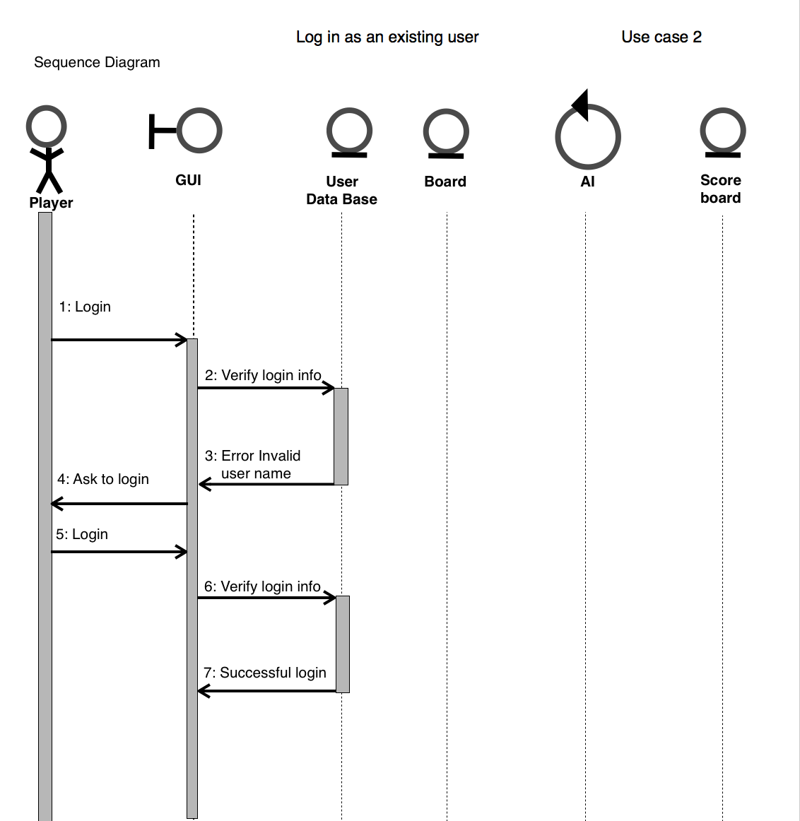

Use case 3(Play as Guest)
General Description
The Play as Guest use case enables the user/actor to choose to play without creating a new account or without logging in. No information is requested from the user and the user can choose to enter the new use case which is to start game in player vs. player mode and player vs. AI mode. This use case does not include the feature of tracking statistics.

Sequence Diagram

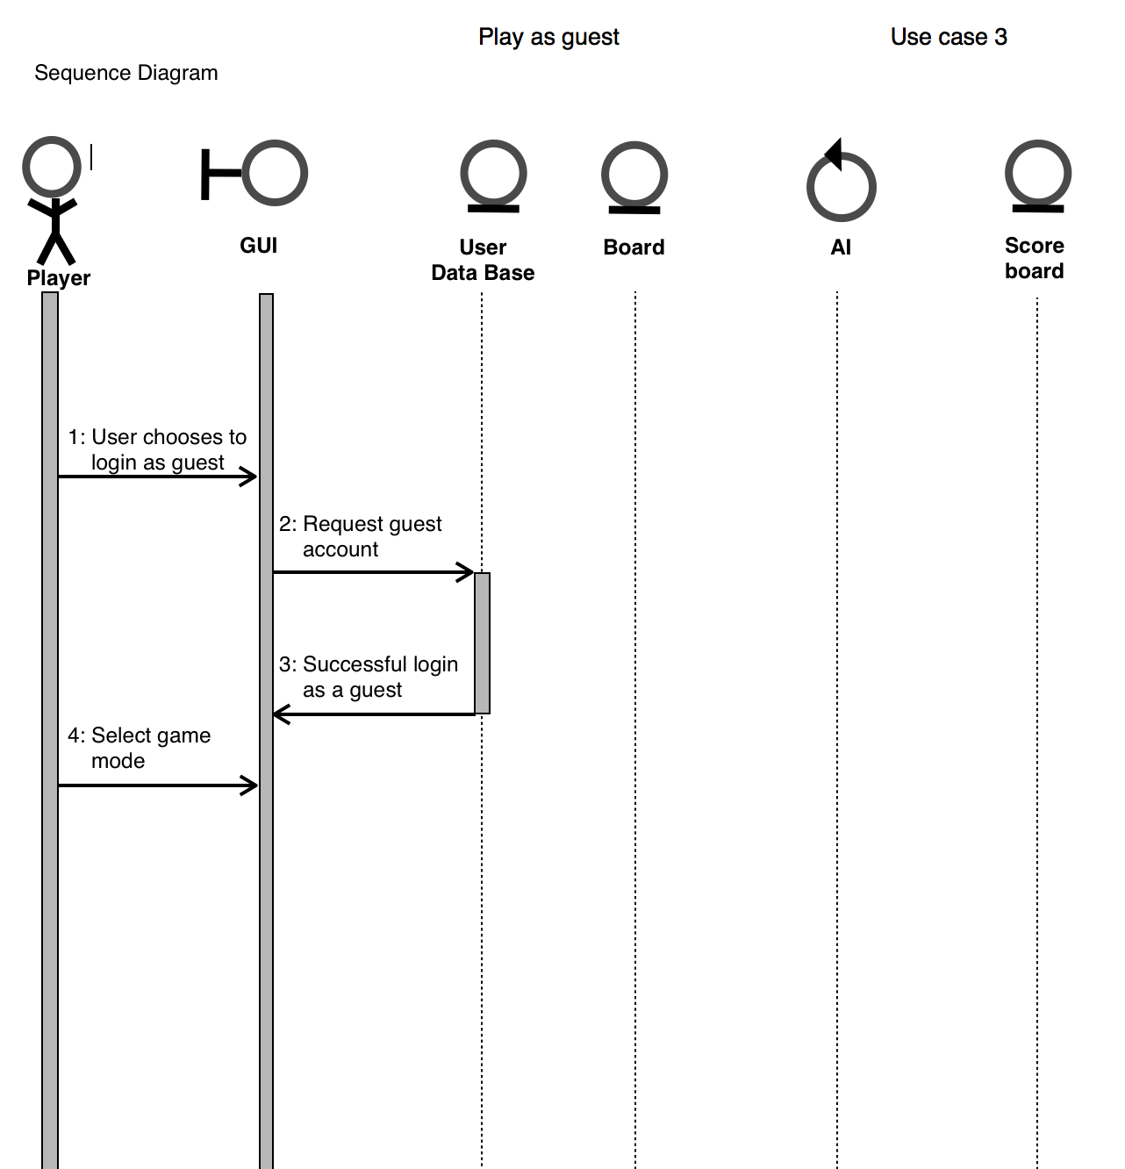

Use case 4(Reset Password)
General Description
The Reset Password use case enables the user to change his/her current password as long as the security question is answered correctly. The only information requested is the first name, last name, username and security answer. The database system updates the new password and the user is then taken to the main window of the program.
Sequence Diagram
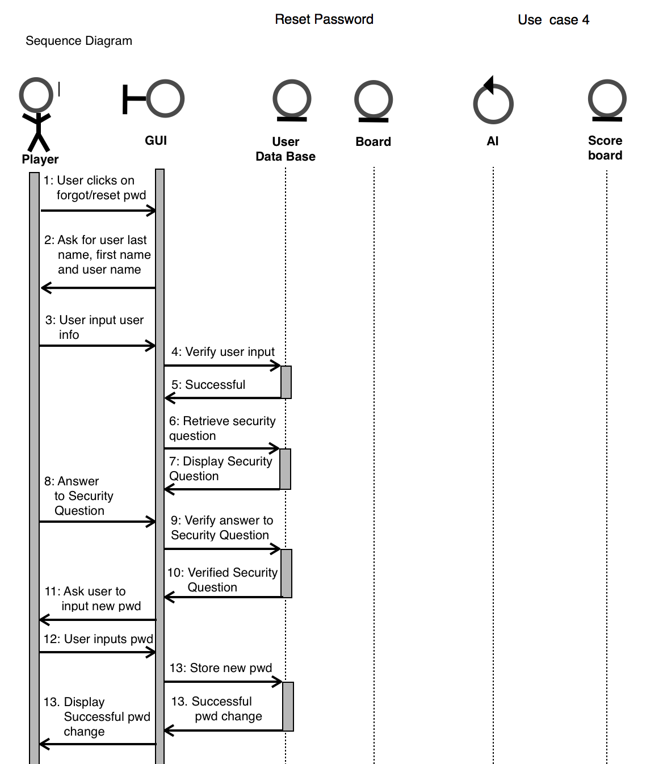

Use case 5(Display Player Statistics)
General Description
The Display Player Statistics enables the user to view his passed games history. This use case is only possible for the registered users and it does not retrieve information from the database if the user is a new registered user with not previously played games.
Sequence Diagram
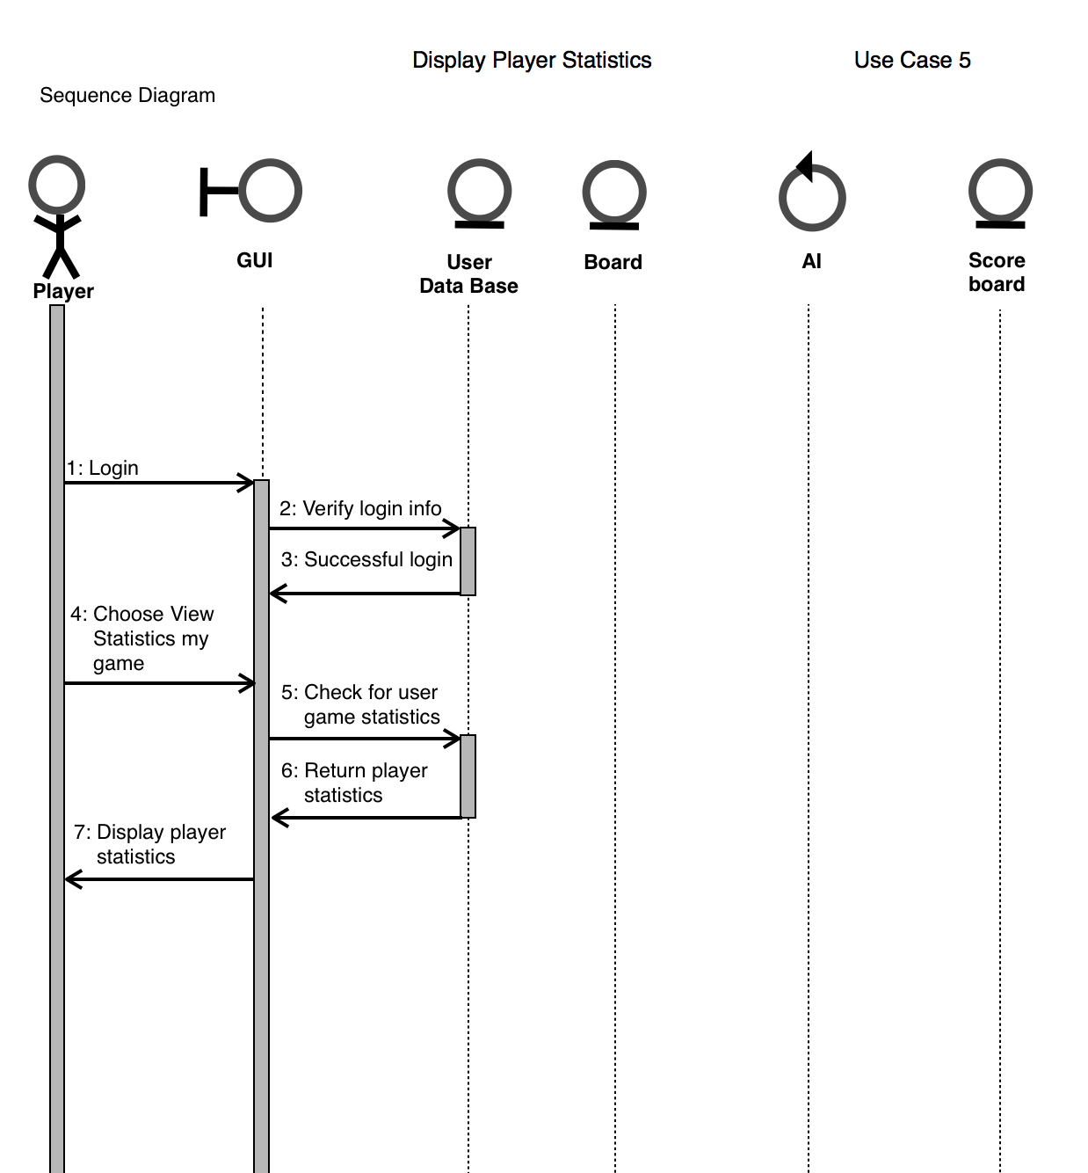

Use case 6(Player vs. Player)
General Description
The Player vs. Player use case enables the user to play against another player. This use case is available to registered user as well as to guest user. In this case the mode of play can only be chosen by the first player and any attempt from the seconds player to change mode will be handled with an error message.
Sequence Diagram
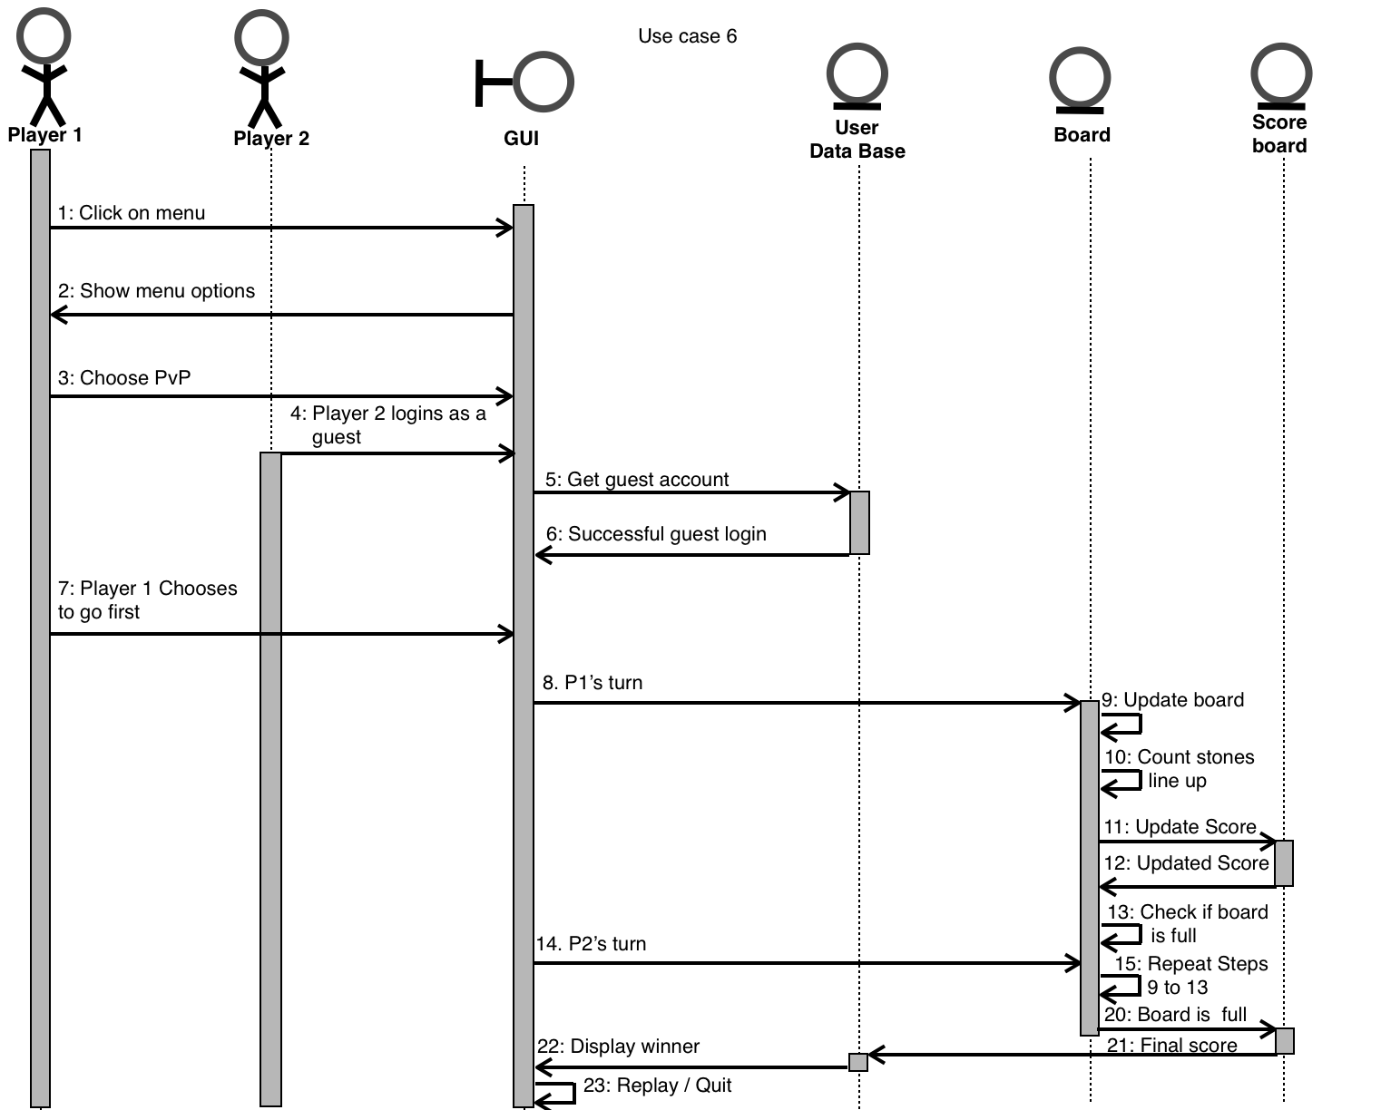

Use case 7(Player vs. AI)

General Description
The Player vs. AI use case enables the user to play against the computer.This use case is available to the registered user as well as to a guest user. In this use case the mode of play can only be chosen by the first player and any attempt from the second player to change mode will be handled with an error message.
Sequence Diagram
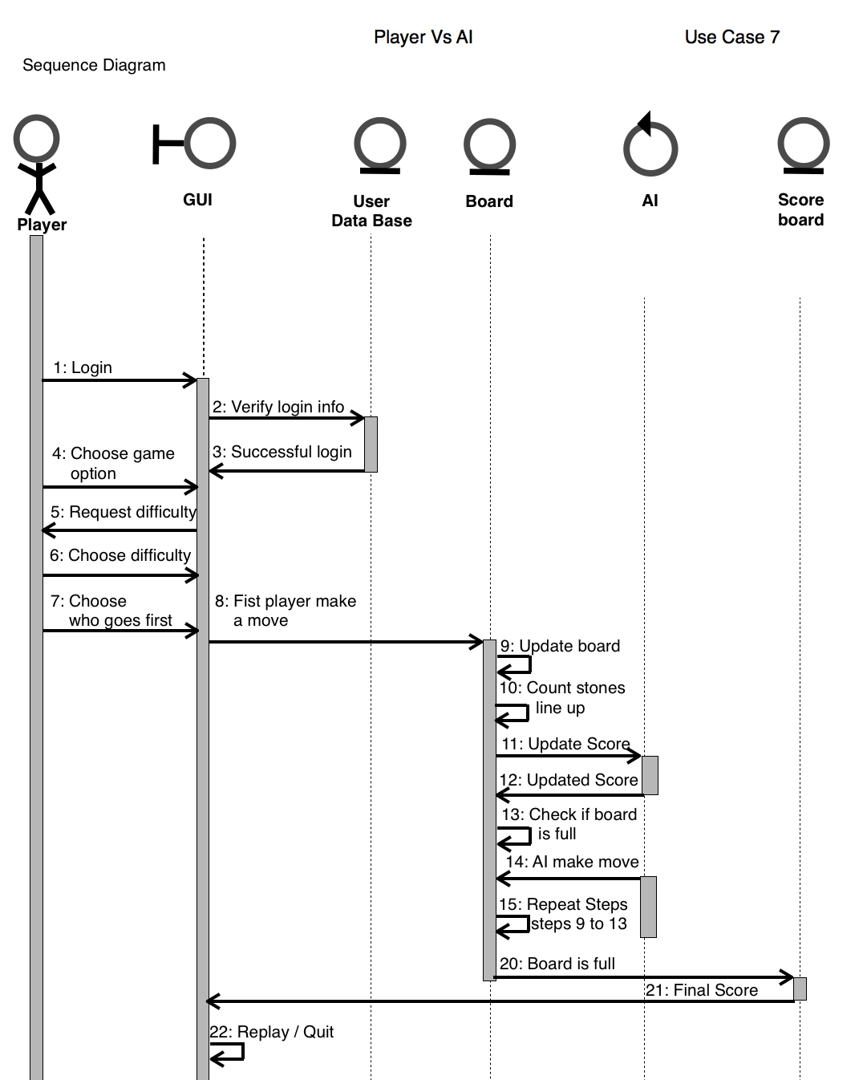

Use case 8(Difficulty Level)
General Description
The Difficulty Level use case enables the user/actor to choose a difficulty level from three given option: easy, medium, hard. This use case is only available to the player vs. AI mode and does not require the user to be a registered user.
Sequence Diagram

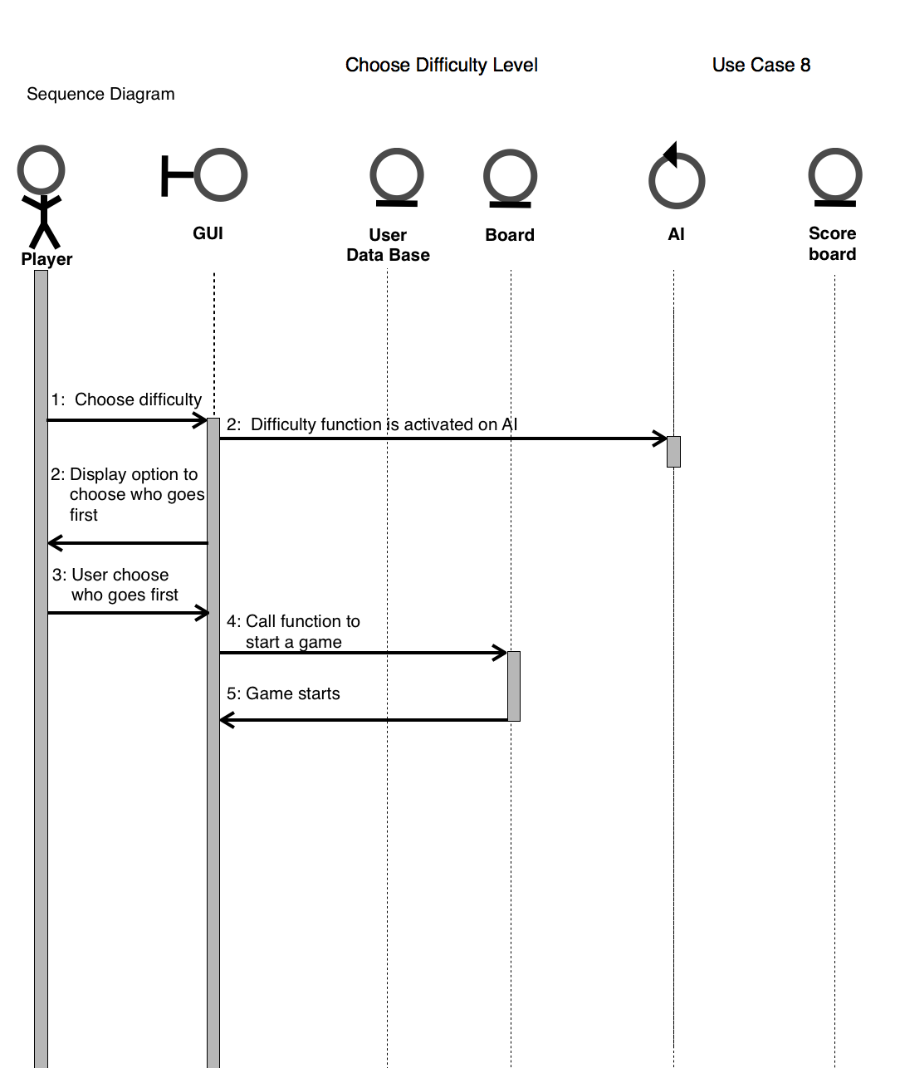

Use case 9(Select title)

General Description
The Select Tile use case enables the user to choose between X which is blue and O which is red.
Sequence Diagram
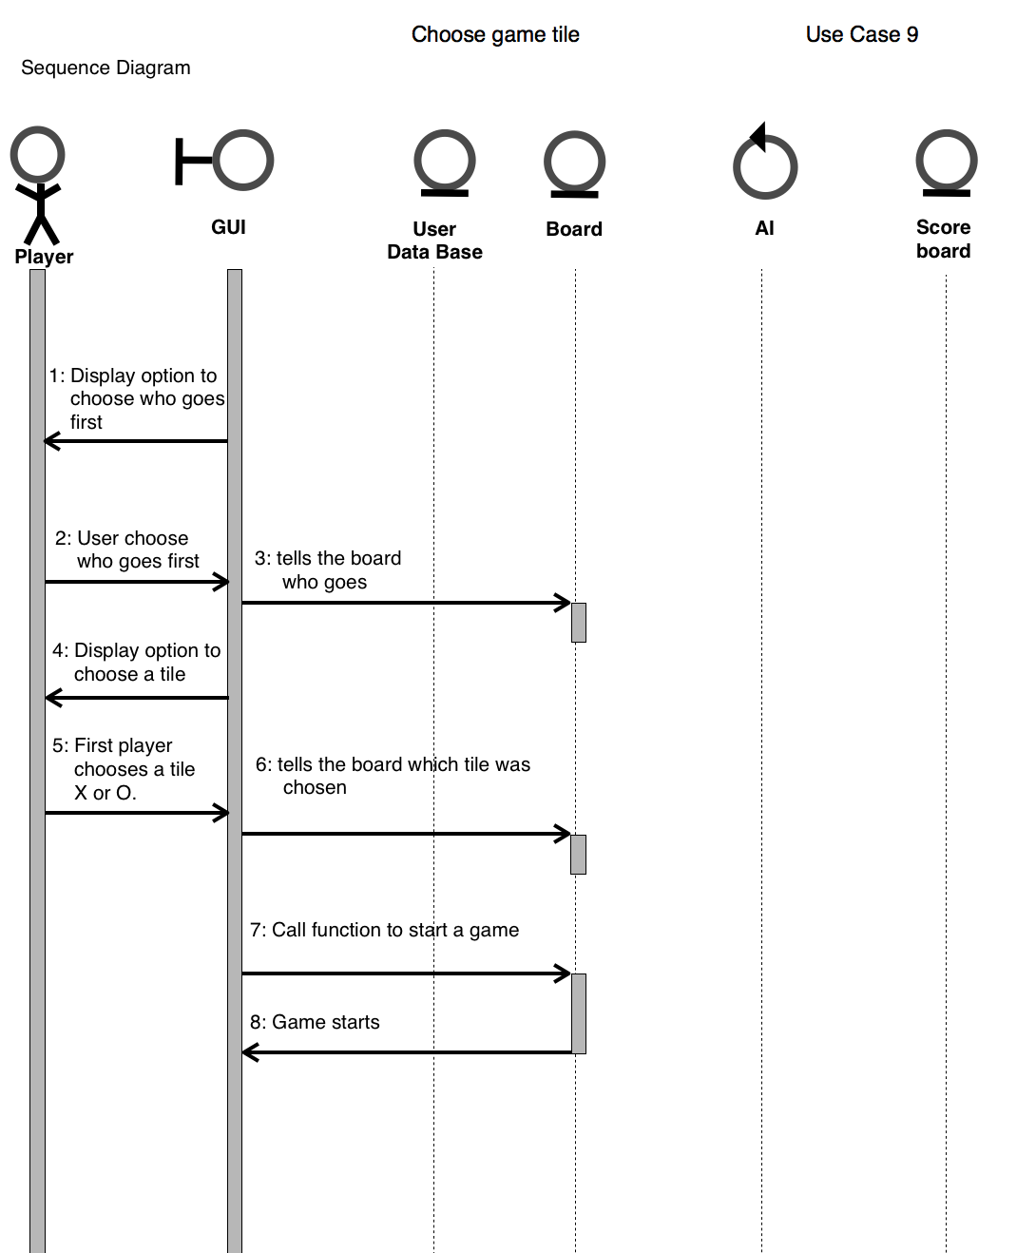

Use case 10(Select First Player)

General Description
The Select First Player use case enables the user to choose who will go first. It decides this based on the tile the player selected, it either lets tile X go first and tile O second or tile O first and tile X second.

Sequence Diagram
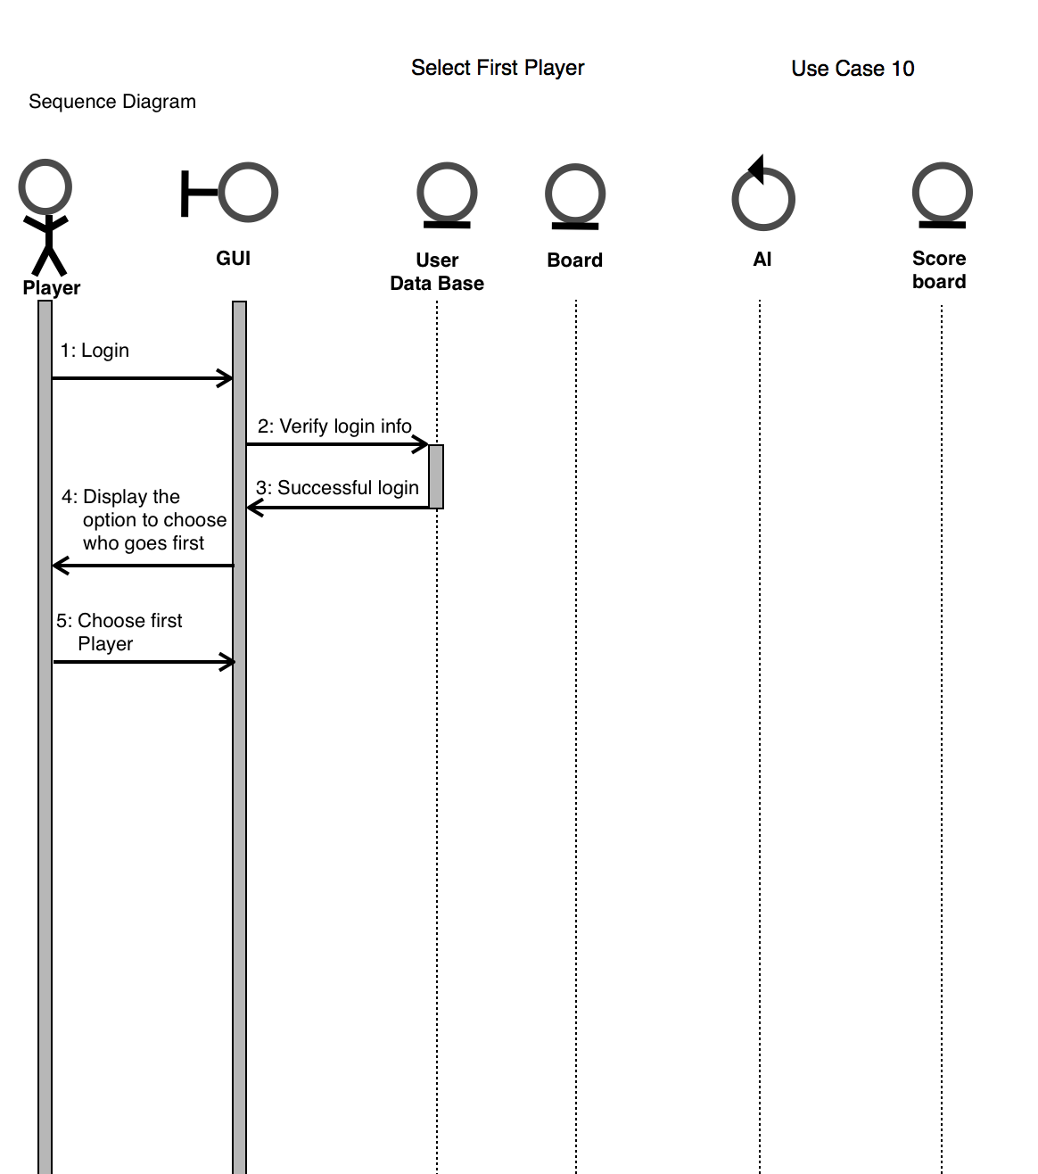

Use case 11(Exit)

General Description
The Exit use case enables the user/actor to close current window to go to previous one. This use case does not automatically exit the game but only allows to go one step back.
Sequence Diagram
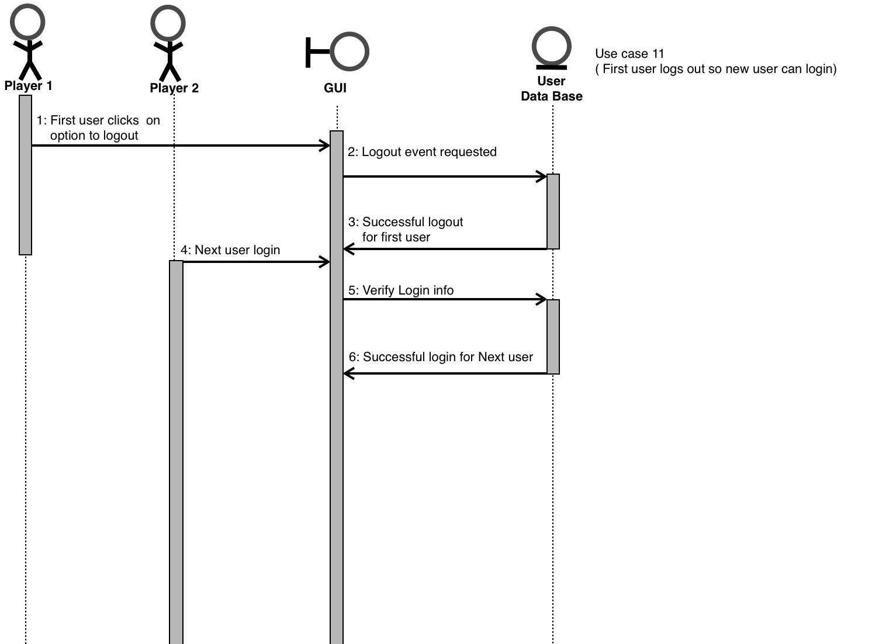

Use case 12(Taken Username)

General Description
The Taken User Name Exception use case enables the actor/user to choose another username in the case that entered one is an existent username in the database. The only information needed is the new username, password, and security question with answer.

Sequence Diagram
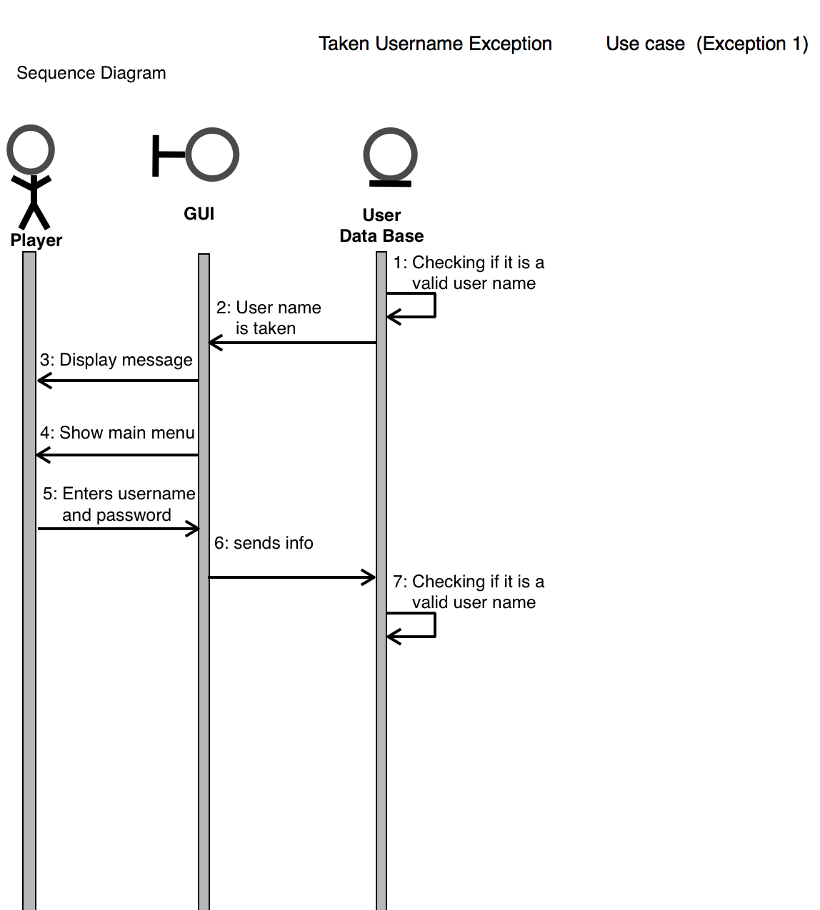

Use case 13(Incorrect Log in information)

General Description
The incorrect log information is an exception use case that handles with the situation when a user tries to logging with incorrect username or password. The information needed for this case is username and password.
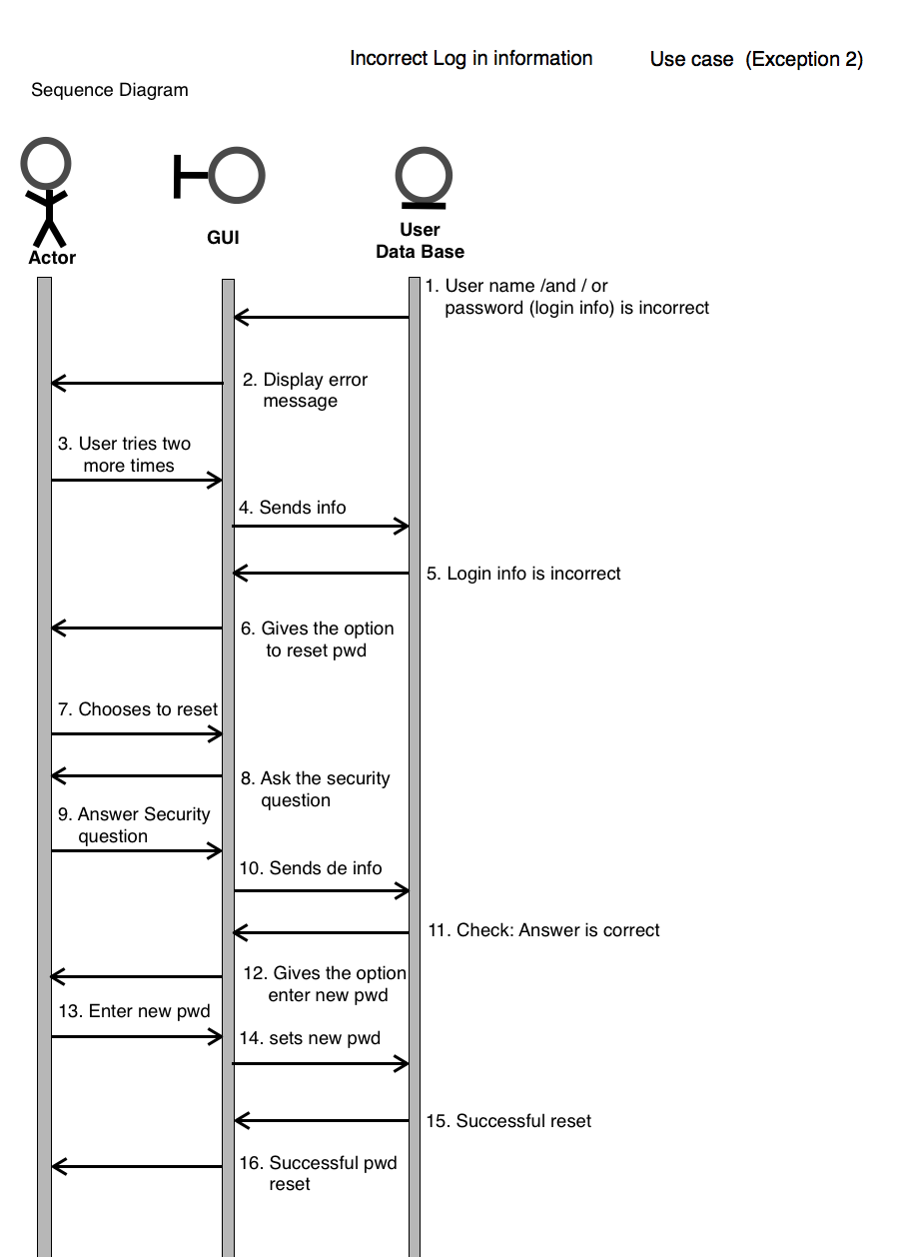
Sequence Diagram

Use case 14(Forgotten Username)
General Description
The forgotten username case handles the event when a user chooses the option forgot password on the main menu. The information needed is user lastname and security question. When the user inputs true value to these field the database will display the username.

Sequence Diagram

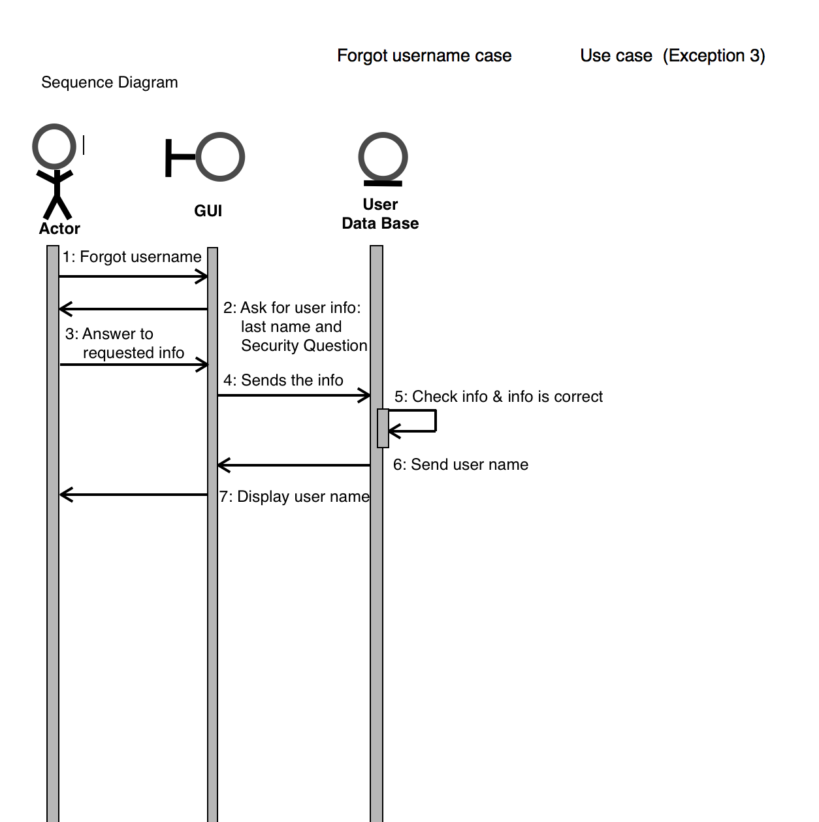

Use case 15 (Incorrect Answer to Security Question)

General Discription
The Incorrect Answer to Security Question handles the event when a user answer not true value to the security question. The information needed is the answer to the security question. If user inputs a not true value to the security question a message incorrect answer will be displayed and the system will prompt the user for answer to security question.
Sequence Diagram
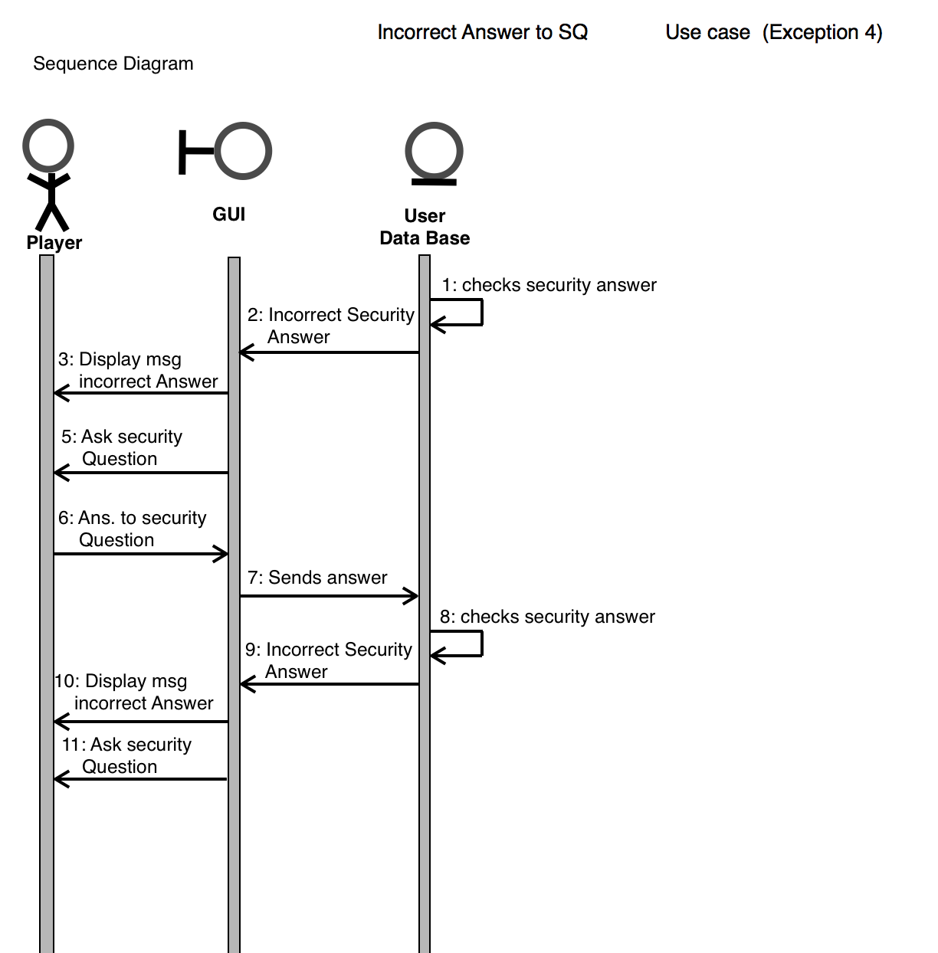

Use case 16 (Statistics for New User)
General Description
The statistics for new user handles the exception when a new user that never played tries to see the statistics of the game. The information need is username and password. When a new user tries to see statistics the system will display a message not statistics for new users.
Sequence Diagram
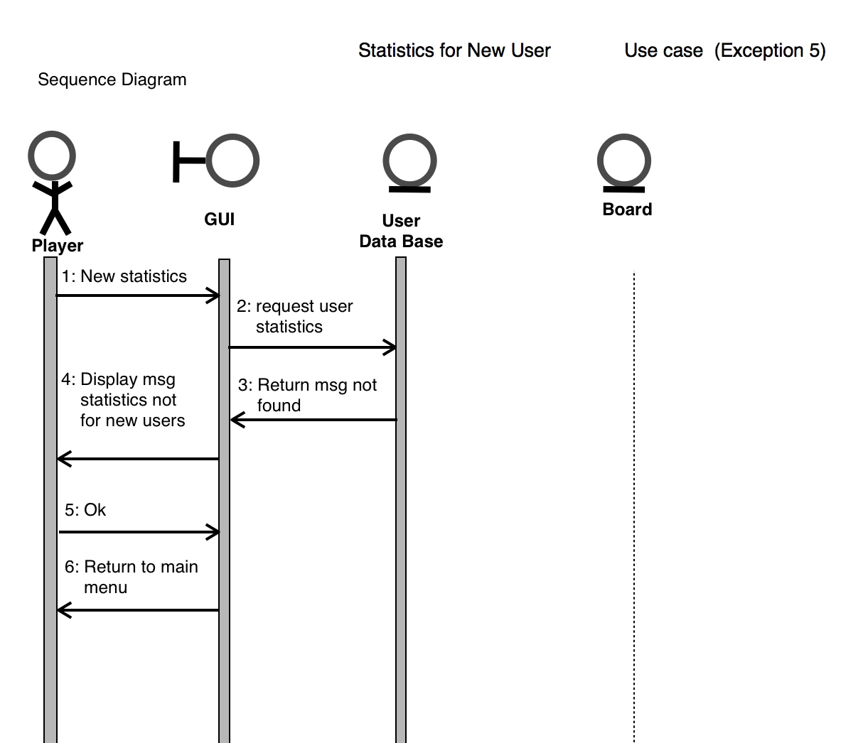

User Interface

Design Documentation
This is a detailed design of all the classes using a program. Here the pseudocode is used for the representation of all our code. It was constructed state diagrams and the overall class diagram.

Finite State Machine Diagrams

- Initiates the Game Board.
- The game has the player choose which mode to play: Player vs Player, Player vs AI, Guest vs Player, and Guest vs AI.
- Creates an X or O.
- The player is prompted to select who goes first.
- Initiate the players turn.
- Once the tile is selected, it is disabled from being selected again.
- The game paints an X or O on the game board.
- Subtracts the counter.
- Update the players score.

- From the main menu, the player clicks the Guest option
  - They are prompted to choose which play mode: Guest vs Player or Guest vs AI
    - If the player needs help, they can click the help button and it will display instructions on how to continue. They will press OK and it will return them back to the play mode option.
  - Once the play mode is chosen, it will start the game
    - However, they can choose the change the game mode and it will exit to the previous menu.
  - Once the game has started, the player can choose to:
    - Quit the game by clicking the Quit Game button
      - They will be prompted with a confirmation window
        - If the player clicks no, it will return to where they left off in the game
        - If the player clicks yes, it will return to the main menu
    - Continue and finish the game
- From the main menu, the player clicks the quit button
  - They will be prompted with a confirmation window
    - If the player clicks no, it will return to the main menu
    - If the player clicks yes, it will exit out of the game

- From the main menu, the player clicks login
  - It asks for the username and password
    - The player can click the Help button
      - It will display instructions to further aid the player
    - They click OK and will be returned to the username and password window
  - The player clicks submit
    - Login successful
      - They click OK and it returns them to the main menu
- From the main menu, the player clicks quit
  - They will be prompted with a confirmation window
    - If the player clicks no, it will return to the main menu
    - If the player clicks yes, it will exit out of the game

- Player vs AI mode
  - The player selects the difficulty they want
    - The user is prompted to choose between X or O
      - They can click Help button
        - It will display instructions to further aid the player
          - They click OK and are returned to the selection of X or O
    - Once the user selects the stone they like, they are prompted again to choose who goes first
      - Once the player is selected, the game starts and the player can choose to:
        - Quit the game by clicking the Quit Game button
          - They will be prompted with a confirmation window
            - If the player clicks no, it will return to where they left off in the game
            - If the player clicks yes, it will return to the main menu
        - Continue and finish the game
  - The player can logout
    - It will end the session
      - Return to the main menu
  - The player can click on the exit button
      - They will be prompted with a confirmation window
        - If the player clicks no, it will return to where they left
        - If the player clicks yes, it will return to the main menu

- Player vs Player mode
  - They can click the Help button
    - It will display instructions to further aid the player
      - They will click OK and are returned to the Player vs Player mode
  - Once the player makes the Player vs Player selection, they are prompted to choose which player goes first
    - They can click the Help button
      - It will display instructions to further aid the player
        - They will click OK and are returned to select which player goes first
  - When they select which player goes first, the game starts
    - They can click Help button
      - It will display instructions to further aid the player
        - They will click OK and are returned to the game
  - Once the player is selected, the game starts and the player can choose to:
    - Quit the game by clicking the Quit Game button
      - They will be prompted with a confirmation window
        - If the player clicks no, it will return to where they left off in the game
        - If the player clicks yes, it will return to the main menu
      - Continue and finish the game
  - The player can click on the exit button
      - They will be prompted with a confirmation window
        - If the player clicks no, it will return to where they left off
        - If the player clicks yes, it will return to the main menu

- Main menu
  - The user clicks the Sign-Up button
    - If the user clicks exit, they are returned to the main menu
      - It asks for the user’s information, such as
        - Username
        - Password
        - First name
        - Last name
        - Security question
        - Security answer
      - They can click the Help button
        - It will display instructions to further aid the player
          - They will click OK and are returned to the sign-up window
      - The player submits their information
        - If there is an error in the user’s information, it will display Unsuccessful Registration
        - If the information is correct, it will display Successful Registration
      - The user clicks OK and is returned to the main menu
  - The user clicks Quit
    - They will be prompted with a confirmation window
      - If the player clicks no, it will return to the main menu
      - If the player clicks yes, it will exit the game

- Main menu
  - The player selects reset password
    - The player can click quit and they will be returned to the main menu
      - They click on forgot username
        - The user will enter their security answer
          - When they click quit, they will be returned to enter the username information
          - They can click the Help button
            - It will display instructions to further aid the player
              - They will click OK and are returned to the username information window
      - They enter their username information
        - They can click the Help button
          - It will display instructions to further aid the player
            - They will click OK and are returned to the username information window
        - Click the Submit button
        - It resets their password successfully
        - Returns the user to the main menu
  - The user clicks Quit

- The player starts a game
  - The first player makes a move
    - It creates a stone and disables the tile so the player can’t create another stone in its place.
      - They can click the Help button
        - It will display instructions to further aid the player
          - They will click OK and are returned to the game
    - It updates and displays the current score after every move
    - It waits for the second player to make a move
      - They player can click exit
        - If they click yes, it will abort the game
        - If they click no, it will return to waiting for the next move
        - They can click the Help button
          - It will display instructions to further aid the player
            - They will click OK and are returned to the game
    - Player two makes a move
  - The player clicks Exit game
    - They will be prompted with a confirmation window
      - If the player clicks no, it will return to the main menu
      - If the player clicks yes, it will return to waiting for the next move

Class Diagram

Pseudo Codes

Pseudo Code for ResetPassword.cpp

resetpassword.cpp

#include “resetpassword.h”
#include “ui_resetpassword.h”
#include <QmessageBox>

//Constructor
resetPassword::resetPassword(QWidget *parent){
create a user interface ibject
create instances of widgets described in ui file
new ui:: resetPassword
}
//Deconstructor
resetPassword::~resetPassword()
{ delete ui; }

resetPassword::resetSumbitButton(){
/*Submit button for resetting password and declare database and set parameters*/
Qsql instance for representing connection
call static addDatabase() function and specify driver (“QMySQL”)
//setting attributes
setHostname
setDatabaseName
setUserName
setPassword

open connection

//Now most information collected will be used to reset password
firstName =resetFirstName
lastName=resetLastName
userName=resetUserName

if(connection fails){
Display message QmessageBox
return
}
else query to get information
search for realLastName, realQuestion, realAnswer;

if(searching fails)
Display error message ;
else {
reset information
realFirstName=searching
realLastName=searching
realQuestion=searching
realAnswer=searching

}
hold provided answer
compare to realAnswer
if(not matching)
{
Display error message(“Answers don't match);
return;
}
else
{ hold newPassword and retypedPassword
Update password to user inputs
Compare if they are the same password
while(not matching)
Display error message(“passwords don't match')
Hold the new entered password again
Compare again
}
Update password
if(update if successful)
{
Display message(“Password Update”)
close connection
}
else Display error message ;
}

resetPassword::resetHelpButton(){
MessageBox onHelp
give instructions
}

Pseudo Code for selectgamemode.cpp

selectgamemode.cpp

#include “selectgamemode.h”
#include “ui_selectgamemode.h”
#include “difficultylevel.h”

//Constructor
selectGameMode::selectGameMode (Qwidget *parent) :
Create a selectGameMode user interface object
Create instances of widgets described in ui file

//Destructor
selectGameMdode::~selectGameMode()
{ delete ui ; }

selectGameMode::okButton(){
if(no mode is selected)
{ Display message(“Select game mode”);

else if (mode was selected)
{ Select a difficulty level now
difficultyLevel selectLevel
close ()
}
else call gameBoard
startGame
}
selectGameMode::BackButton(){
close current window

Pseudo Code for gamemode.cpp

#include "gamemode.h"
#include "ui_gamemode.h"
#include "gameoption.h"
#include "difficultylevel.h"
#include "playergameoptions.h"
#include <QMessageBox>
#include <QLineEdit>
#include <QDebug>

gameMode::gameMode(QWidget *parent) : QDialog(parent), ui(new Ui::gameMode)
{
ui->setupUi(this);
}

gameMode::~gameMode() //destructor
{
delete ui;
}

void gameMode :: switchingMode ()
{

}

void gameMode::on_GameOptionMode_clicked()
{
//this is going to determine either player vs player
//or player vs AI

//using a combobox to select choice
switchingMode ();
//ui->GamePlayMode->itemIcon(2);
if(ui->GamePlayMode->currentIndex() == 0)
{
QMessageBox :: information(this,tr("Make a choice"),tr("Please select player vs player or Player vs A.I"));
}
else if(ui->GamePlayMode->currentIndex() == 1)
{
//calls the player vs player function

PlayerGameOptions playerVsPlayer;
playerVsPlayer.setModal(true);
playerVsPlayer.exec();
close();
}
else if (ui->GamePlayMode->currentIndex() == 2)
{
//for player vs a.i.
//prompts user for difficulty of a.i.

difficultyLevel myLevel;
myLevel.setModal(true);
myLevel.exec();
close();
}
else
{
//an exception handler for combobox
QMessageBox :: information(this,tr("Make a choice"),tr("Please select player vs player or Player vs A.I"));
}
}

Pseudo code for aiclass.cpp

#include "aiclass.h"
#include "gameboard.h"
#include "time.h"
#include "difficultylevel.h"
#include <QPoint>
#include <QMessageBox>
#include <QGraphicsSceneMouseEvent>
#include <QGraphicsRectItem>
#include <QDebug>
#include <QPainter>

int takingTurns = 1; //global variables for board and turn

AiClass* board[6][6];
bool AiTurn = false;
int numbOfSquaresLeft =36;

void AiClass::AiBoard()
{

//now this is going to design the board with some menu on the board

QGraphicsScene * myScene = new QGraphicsScene ();
QGraphicsView * myView = new QGraphicsView (myScene);
QGraphicsTextItem * text = new QGraphicsTextItem ();
text->setTextInteractionFlags(Qt::TextEditable);
text->setPlainText("1");
text->setPlainText("2");
text->setPlainText("3");

//display, user ID, score, and amount of turns

myScene->addText(
"Username: "+username+" \tScore: "+"\t\tUsername2: AI"+
"\tScore2: "+"\t\tAiLevel: "
)->mapToScene(0.0,0.0).toPoint();
myView->setFixedSize(800,900);
int left=100, right=100, up=100, down=100;
//for loop to initialze boar
for (int x=0; x< 6; x++)
{
for(int y = 0; y < 6; y++) //changed all y
{
//now drawing the board by using QGraphicsRectItem

board[x][y] = new AiClass ();
board[x][y]->setPen(QPen(QColor("black"),5));
board[x][y]->setRect(left,right,up,down);
myScene->addItem(board[x][y]);
left+=100;
if(y==5)
{
left=100;
right+=100;
}
}

}

//showing the board and seeding the random generator

myView->show();
srand(time(NULL));
}

//now doing the AI mode

void AiClass :: easyAiMode ()
{
// will be used to generate a random colom and row
int col, row;
col=rand()%6;
row=rand()%6;
if(board[col][row]->isEnabled() == false)
{
//this means if the bord is dissable, i will be repeating the guess

easyAiMode();
}
else
{
//not disable, then i can play it as my board
board[col][row]->playEvent();

AiTurn = false;
}

}

//now doing medium AI mode

void AiClass :: mediumAiMode()
{
//this is the medium Ai Mode
//by using a randomized alrogirthm
//have to make it mor structure and respond towards players move

int col, row;
col=rand()%6;
row=rand()%6;
if(board[col][row]->isEnabled() == false)
{
//this means if the bord is dissable, i will be repeating the guess

mediumAiMode();
}
else
{
//not disable, then i can play it as my board
if(board[3][3]->isEnabled() == true)
{
board[3][3]->playEvent();
}
else
{

}
AiTurn = false;
}
}

void AiClass :: hardAiMode()
{
/*int count = 0;
int ph = -1;
int bestMove;
//string[] game;
game = new string[25]; //game board copy for MINIMAX

for (int j = 0; j < 25; j++) //looks at the board to find any moves
{
if (String.Equals(board[j].Content, "X") || String.Equals(board[j].Content, "O"))
{
count++;
ph = j;
}
}

if (count < 1) // random move in center 9 square
{ // if no moves have been made
centerNine = new List<int>(){6,7,8,11,12,13,16,17,18};
if (ph > 0)
centerNine.Remove(ph);
bestMove = centerNine.ElementAt(random.Next(0, centerNine.Count-1));
Debug.WriteLine("Random move at " + bestMove);
}
else
{ //copies the game board
for (int i = 0; i < 25; i++)
{
if (String.Equals(board[i].Content, "X"))
{
game[i] = "X";
}
else if (String.Equals(board[i].Content, "O"))
{
game[i] = "O";
}
else
{
game[i] = "";
}
}

depth = 0; //sets depth to 0
bestMove = MinMax(game);
}

makeMove(bestMove);*/

}

int AiClass::settingAiLevel(int level)
{
//this funciton is used to design a level
AiLevel = level;
return AiLevel;
}

void AiClass::mousePressEvent(QGraphicsSceneMouseEvent *event)
{
if(AiTurn == false)
{
if(event->button() == Qt::LeftButton)
{
this->playEvent();
}

}

AiTurn = true;
mouseReleaseEvent(event);

}

void AiClass::mouseReleaseEvent(QGraphicsSceneMouseEvent *event)
{
if(AiTurn == true && AiLevel == 3)
{
this->hardAiMode();
}
else if(AiTurn == true && AiLevel == 2)
{
this->mediumAiMode();
}
else
{
this->easyAiMode();
}

}

void AiClass :: playEvent()
{
if(takingTurns == 1)
{
this->setBrush(QPixmap(":/images/X.png"));
}
else
{
this->setBrush(QPixmap(":/images/O_file.png"));
}
this->setData(takingTurns,QVariant::QVariant(takingTurns));
this->setEnabled(false);
takingTurns *= -1;
numbOfSquaresLeft-=1;
if(numbOfSquaresLeft <=29)
checkingWinners();
if(numbOfSquaresLeft == 0)
{
QMessageBox * endGame = new QMessageBox ();
endGame->setInformativeText("call the end Game");
endGame->show();
}
}

void AiClass::checkingWinners()
{
//this funciton will check for winners

//first checking horizontally

int red=0, blue=0;
int tempred =0, tempblue = 0;

for (int x = 0; x < 6; x++)
{
for (int y=0; y < 6; y++)
{
if(board[x][y]->data(takingTurns).toInt() == 1)
tempblue++;
else if(board[x][y]->data(takingTurns).toInt() == -1)
tempred++;
}

if(tempred % 6 == 0)
red+=3;
else if(tempred %5 == 0)
red+=3;
else
red = tempred/4;

//now for blue

if(tempblue %6 == 0)
blue+=3;
else if(tempblue % 5 == 0)
blue+=2;
else
blue = tempblue/4;
}
//increasing score for x

/*if(tempblue%6 == 0)
blue=(tempblue/6)*3;
else if(tempblue%5 == 0)
blue=(tempblue/5)*2;
else if(tempblue%4 == 0)
blue = tempblue/4;
else
{
blue = tempblue/4;
tempblue=0;
}

qDebug() << blue;

//increasing the score for red

/*if(tempred%6 == 0)
red=(tempred/6)*3;
else if(tempred%5 == 0)
red=(tempred/5)*2;
else
{
red = tempred/4;
tempred=0;
}

//now checking vertically

for(int y=0; y < 6; y++)
{
int x=0;
if(board[x][y]->data(takingTurns).toInt() == 1 && board[x+1][y]->data(takingTurns).toInt()== 1 && board[x+2][y]->data(takingTurns).toInt()== 1 && board[x+3][y]->data(takingTurns).toInt()== 1)
{
blue++;
//draw();;
}
if(board[x+1][y]->data(takingTurns).toInt() == 1 && board[x+2][y]->data(takingTurns).toInt()== 1 && board[x+3][y]->data(takingTurns).toInt()== 1 && board[x+4][y]->data(takingTurns).toInt()== 1)
{
blue++;
//draw();;
}
if(board[x+2][y]->data(takingTurns).toInt() == 1 && board[x+3][y]->data(takingTurns).toInt()== 1 && board[x+4][y]->data(takingTurns).toInt()== 1 && board[x+5][y]->data(takingTurns).toInt()== 1)
{
blue++;
//draw();;
}
if(board[x][y]->data(takingTurns).toInt() == -1 && board[x+1][y]->data(takingTurns).toInt()== -1 && board[x+2][y]->data(takingTurns).toInt()== -1 && board[x+3][y]->data(takingTurns).toInt()== -1)
{
red++;
////draw();;
}
if(board[x+1][y]->data(takingTurns).toInt() == -1 && board[x+2][y]->data(takingTurns).toInt()== -1 && board[x+3][y]->data(takingTurns).toInt()== -1 && board[x+4][y]->data(takingTurns).toInt()== -1)
{
red++;
//draw();;
}
if(board[x+2][y]->data(takingTurns).toInt() == -1 && board[x+3][y]->data(takingTurns).toInt()== -1 && board[x+4][y]->data(takingTurns).toInt()== -1 && board[x+5][y]->data(takingTurns).toInt()== -1)
{
red++;
////draw();;
}
}

//now chekcing for diagonal

int y=5;
int tempred=0, tempblue=0;
for (int x=0; x < 6; x++)
{
if(board[x][y]->data(takingTurns).toInt() == 1)
{
tempblue++;
}
else if(board[x][y]->data(takingTurns).toInt() == -1)
{
tempred++;
}
else
y--;
}

if(tempblue == 6)
blue+=3;
else if(tempblue == 5)
blue+=2;
else if(tempblue == 4)
blue+=1;
else
tempblue=0;

//here is to increase red

if(tempred == 6)
red+=3;
else if(tempred == 5)
red+=2;
else if(tempred == 4)
red+=1;
else
tempred=0;

y=5;
for (int x=1; x <6; x++)
{
if(board[y][x]->data(takingTurns).toInt()==1)
tempblue++;
else if(board[y][x]->data(takingTurns).toInt() == -1)
tempred++;
else
y--;
}

y=5;
for (int x=2; x < 6; x++)
{
if(board[y][x]->data(takingTurns).toInt()==1)
tempblue++;

else if(board[y][x]->data(takingTurns).toInt() == -1)
tempred++;

else
y--;
}
if(tempblue == 6)
blue+=3;
else if(tempblue == 5)
blue+=2;
else if(tempblue == 4)
blue+=1;
else
tempblue=0;

//here is to increase red

if(tempred == 6)
red+=3;
else if(tempred == 5)
red+=2;
else if(tempred == 4)
red+=1;
else
tempred=0;

y=4;
for(int x=0; x <5; x++)
{
if(board[x][y]->data(takingTurns).toInt() == 1)
tempblue++;
else if(board[x][y]->data(takingTurns).toInt()==-1)
tempred++;
else
y--;
}

if(tempblue == 6)
blue+=3;
else if(tempblue == 5)
blue+=2;
else if(tempblue == 4)
blue+=1;
else
tempblue=0;

//here is to increase red

if(tempred == 6)
red+=3;
else if(tempred == 5)
red+=2;
else if(tempred == 4)
red+=1;
else
tempred=0;

y=3;
for(int x=0; x < 4; x++)
{
if(board[x][y]->data(takingTurns).toInt()==1)
tempblue++;
else if(board[x][y]->data(takingTurns).toInt()==-1)
tempred++;
else
y--;
}
if(tempblue == 6)
blue+=3;
else if(tempblue == 5)
blue+=2;
else if(tempblue == 4)
blue+=1;
else
tempblue=0;

//here is to increase red

if(tempred == 6)
red+=3;
else if(tempred == 5)
red+=2;
else if(tempred == 4)
red+=1;
else
tempred=0;

//now doing the opposite direction

for(int x=0; x < 6; x++)
{
if(board[x][x]->data(takingTurns).toInt() == 1)
tempblue++;
else if(board[x][x]->data(takingTurns).toInt() == 1)
tempred++;
else
x++;
}
if(tempblue == 6)
{
blue+=3;
////draw();;
}
else if(tempblue == 5)
{
blue+=2;
////draw();;
}
else if(tempblue == 4)
{
blue+=1;
////draw();;
}
else
tempblue=0;

//here is to increase red

if(tempred == 6)
{
red+=3;
}
else if(tempred == 5)
{
red+=2;
////draw();;
}
else if(tempred == 4)
{
red+=1;
////draw();;
}
else
tempred=0;

for (int x=0; x < 5; x++)
{
if(board[x][x+1]->data(takingTurns).toInt())
tempblue++;
else if(board[x][x+1]->data(takingTurns).toInt())
tempred++;
else
x++;
}
if(tempblue == 6)
{
blue+=3;
}
else if(tempblue == 5)
{
blue+=2;
////draw();;
}
else if(tempblue == 4)
{
blue+=1;
////draw();;
}
else
tempblue=0;

//here is to increase red

if(tempred == 6)
{
red+=3;
////draw();;
}
else if(tempred == 5)
{
red+=2;
//draw();;
}
else if(tempred == 4)
{
red+=1;
////draw();;
}
else
tempred=0;

for (int x=0; x < 5; x++)
{
if(board[x][x+2]->data(takingTurns).toInt() == 1)
tempblue++;
else if(board[x][x+2]->data(takingTurns).toInt() == 1)
tempred++;
else
x++;

if (x+2 ==5)
break;
}
if(tempblue == 6)
{
blue+=3;
////draw();;
}
else if(tempblue == 5)
{
blue+=2;
//draw();;
}
else if(tempblue == 4)
{
blue+=1;
////draw();;
}
else
tempblue=0;

//here is to increase red

if(tempred == 6)
{
red+=3;
////draw();;
}
else if(tempred == 5)
{
red+=2;
////draw();;
}
else if(tempred == 4)
{
red+=1;
////draw();;
}
else
tempred=0;

y=0;
for (int x=2; x < 6; x++)
{
board[x][y];
y++;
}
if(tempblue == 6)
{
blue+=3;
////draw();;
}
else if(tempblue == 5)
{
blue+=2;
//draw();;
}
else if(tempblue == 4)
{
blue+=1;
//
}
else
tempblue=0;

//here is to increase red

if(tempred == 6)
{
red+=3;
////draw();;
}
else if(tempred == 5)
{
red+=2;
////draw();;
}
else if(tempred == 4)
{
red+=1;
////draw();;
}
else
tempred=0;

y=0;
for (int x=1; x < 6; x++)
{
if(board[x][y]->data(takingTurns).toInt() == 1)
tempblue++;
else if(board[x][y]->data(takingTurns).toInt() == -1)
tempred;
else
y++;
}
if(tempblue == 6)
{
blue+=3;
////draw();;
}
else if(tempblue == 5)
{
blue+=2;
////draw();;
}
else if(tempblue == 4)
{
blue+=1;
////draw();;
}
else
tempblue=0;

//here is to increase red

if(tempred == 6)
{
red+=3;
////draw();;
}
else if(tempred == 5)
{
red+=2;
////draw();;
}
else if(tempred == 4)
red+=1;
else
tempred=0;*/

//later on, upgrade the scores, and paint.
}

void AiClass:: drawingEvent (int left, int right,int up, int down)
{
//this is going to draw on the board
left=0,right=0,up=0,down=0;

QGraphicsLineItem * newPainting = new QGraphicsLineItem ();
newPainting->setPen(QPen(QColor("Green"),20));
newPainting->setLine(110,150,490,150);

//vertical
newPainting->setLine(150,110,150,490);

//diagonal
newPainting->setLine(100,100,500,500);
}

Pseudo code for gameboard.cpp

#include "gameboard.h"
#include "ui_gameboard.h"
#include <time.h>
#include <QGraphicsScene>
#include <QGraphicsItem>
#include <QGraphicsRectItem>
#include <QGraphicsView>
#include <QDebug>
#include <QPixmap>
#include <QMouseEvent>
#include <QMenuBar>
#include <QMessageBox>

int squaresLeft=36, turn = 1; //global variables for board and turn

QString Username;
CustomItem * myBoard[6][6];

void CustomItem :: mousePressEvent(QGraphicsSceneMouseEvent *event)
{
if(event->button() == Qt::LeftButton)
{
this->playEvent();

}

}

//mouse release event in order to make the

QString gameBoard:: setUsername (QString username)
{
Username = username;
return username;
}

void CustomItem :: playEvent ()
{
if(turn== 1)
{
this->setBrush(QPixmap(":/images/X.png"));
}
else
{
this->setBrush(QPixmap(":/images/O_file.png"));
}
this->setData(turn,QVariant::QVariant(turn));
this->setEnabled(false);
turn *= -1;
squaresLeft=squaresLeft-1;
if(squaresLeft == 0)
{
QMessageBox * endGame = new QMessageBox ();
endGame->setInformativeText("call the end Game");
endGame->show();
}
}
//now adding a menu content in our board
gameBoard::gameBoard(QWidget *parent) : QDialog(parent), ui(new Ui::gameBoard)
{
ui->setupUi(this);
this->setMouseTracking(true);
}

gameBoard::~gameBoard()
{
delete ui;
}

void gameBoard::gameStart()
{
//now this is going to design the board with some menu on the board

QGraphicsScene * myScene = new QGraphicsScene ();

QGraphicsView * myView = new QGraphicsView (myScene);

//display, user ID, score, and amount of turns

myScene->addText("UserID: "+Username+" \t\tScore: "+"\t\tTurns: ")->mapToScene(0.0,0.0).toPoint();
myView->setFixedSize(800,900);
myView->setMouseTracking(true);

//build the array of board

//pixel sizes of the four dimensions

int left=100, right=100, up=100, down=100;

//for loop to initialze boar
for (int x=0; x< 6; x++)
{
for(int y = 0; y < 6; y++) //changed all y
{
//now drawing the board by using QGraphicsRectItem

myBoard[x][y] = new CustomItem ();
myBoard[x][y]->setRect(left,right,up,down);
myScene->addItem(myBoard[x][y]);
left+=100;

if(y==5)
{
left=100;
right+=100;
}
}
}
//display board

myView->show();

}

void gameBoard :: settingTurn()
{
//this will change the global variable of the turn
turn = -1;
}

Pseudo code for gameboard.cpp

#include "playergameoptions.h"
#include "ui_playergameoptions.h"
#include "gameboard.h"
#include <QMessageBox>

PlayerGameOptions::PlayerGameOptions(QWidget *parent) : QDialog(parent), ui(new Ui::PlayerGameOptions)
{
ui->setupUi(this);
}

PlayerGameOptions::~PlayerGameOptions()
{
delete ui;
}

void PlayerGameOptions::on_pushButton_clicked()
{
//allows user to choose either X or O

if(ui->playerGameOption->currentIndex()== 0)
{
//if default item is chosen in combo box
QMessageBox :: information(this,tr("Game Information"),tr("Choose between X and O"));
}
else if(ui->playerGameOption->currentIndex() == 1)
{
//starts the game with player 1 as X and player2 as O
gameBoard * initBoard = new gameBoard();
initBoard->gameStart();
close();
}
else if(ui->playerGameOption->currentIndex() == 2)
{
//starts the game with player 1 as O and player2 as X

gameBoard * initBoard = new gameBoard();
initBoard->settingTurn();
initBoard->gameStart();
close();
}
else
{
//Exception handler
QMessageBox :: information(this,tr("Game Information"),tr("Choose between X and O"));
}

}

void PlayerGameOptions::on_playerOptionHelpButton_clicked()
{
//Help button
QMessageBox :: information(this,tr("help button"),tr("Choose to go either as X or O"));
}

Pseudo code for difficultylevel.cpp

#include "difficultylevel.h"
#include "ui_difficultylevel.h"
#include "gameoption.h"
#include "aiclass.h"
#include <QMessageBox>
#include <QDebug>

difficultyLevel::difficultyLevel(QWidget *parent) :
QDialog(parent),
ui(new Ui::difficultyLevel)
{
ui->setupUi(this);
ui->playGameButton->setEnabled(false);
ui->logOutButton->setEnabled(false);
}

difficultyLevel::~difficultyLevel()
{
delete ui;
}

void difficultyLevel::on_mediumButton_clicked()
{
//return 2; //for the meduim level of a.i.
if (ui->mediumButton->isChecked())
ui->playGameButton->setEnabled(true);
}

void difficultyLevel::on_hardButton_clicked()
{
//return 3; //for the hard level of a.i.
if(ui->hardButton->isChecked())
ui->playGameButton->setEnabled(true);
}

void difficultyLevel::on_logOutButton_clicked()
{
//this is the logout button

QMessageBox logoutMessage;
logoutMessage.setText("Thank you for playing "); //message for logout
logoutMessage.exec();
close();
}

void difficultyLevel::on_exitButton_clicked()
{
//close form
close();
}

void difficultyLevel::on_difficultyHelpButton_clicked()
{
//this is the help button

QMessageBox helpMessage;
helpMessage.setText("Please choose Easy, Medium or hard and press play"); //message
helpMessage.exec();
}

void difficultyLevel::on_easyButton_clicked()
{
//this is enabling the playGameButton
if(ui->easyButton->isChecked())
ui->playGameButton->setEnabled(true);
}

void difficultyLevel::on_playGameButton_clicked()
{
//now this button will call the game mode based on what which is selected and play

if(ui->hardButton->isChecked())
{
AiClass hardMode;
hardMode.settingAiLevel(3);
hardMode.hardAiMode();
close();
}
else if(ui->mediumButton->isChecked())
{
AiClass mediumMode;
mediumMode.settingAiLevel(2);
mediumMode.mediumAiMode();
close();
}
else
{
AiClass staringGame;
staringGame.AiBoard();
staringGame.settingAiLevel(1);
close();
}

Pseudo Code for registrationScene.cpp

registrationscene.cpp

Constructor
registrationScene::registrationScene(QWidget *parent){
Create a registration user interface object
Create instances of widgets described in Ui file
}
Destructor
registrationScene::~registrationScene(){
delete ui;
}

registrationScene::signUpButton(){
/*Function to write SQL codes to connect to the database and check username, password, etc
make connection to a database (MySQL). */

setting hostName
setting databasaName
setting userName
settingPassword
Now QSQLDatabase class instance that represents a connection
call static addDatabase function
and specify driver (“QMYSQL”)

//Next check that the inputs gathered from ui math by using compare function
if(inputs don’t match)
Display QMessageBox with message error
else
send info to database

if (not Okay )
report an error occurred during connection to database
Message::critical(“Error”)
return;

else
assign values to signUpQuery;
if (signUpQuery is successful in exec())
Display QMessageBox (“Thank you for signing up”) ;

else Display another error of possible mismatch
QMessageBox(“Possible mismatch”)

close database connection
}

}

registrationScence::helpButton(){
//Provide help t user
QMessageBox(“Confirm password”)

}

Pseudo Code for gameoption.cpp

gameoption.cpp

#include “gameoption.h”
#include “ui_gameoption.h”
#include “gameboard.h”
#include “difficulty llevel.h”

//Constructor
gameOption::gameOption(QWidget *parent) :
Create a gameOption user interface object
Create instances of widgets described in Ui file

//Deconstructor
gameOption::~gameOption()
{ delete ui; }

gameOption::gameOptionOkay(){
if(user chooses to go first)
{
create new board
start game
close
}
else if(user chooses to go second)
{
create a playerVsAi board
start game
close
}
else Display message box (“Please select game mode”)
}

Pseudo Code for maintictactoe.cpp

mainTicTacToe.cpp

/*constructor takes object of QWidget type as parameter for user interface
to receive mouse, keyboard an other events from window system.*/
Constructor
{
if ( QWidget parameter parent is equal to 0, then widget will be a window)
{

QMainWindow(parent)
//Construct a QMainWindow with given parent

new Ui window mainTicTacToe
//Creating instances of widgets described in ui file

}

Destructor
{ delete ui}

mainTicTacToe :: helpButton(){
//inform of ask user
QMessageBox (“Choose option to play as guest or as user”)
}

mainTicTacToe::quitButton(){
QMessagebox: Gives option to quit
Standards button Yes or No
Check if (yes to quit )
call quit() function
else do nothing at that moment, keep the game running
}

mainTicTacToe::loginButton() {
//this function is going to create a new window or scene to bring username and //password
Dialog class is implemented to set modal to true

//now use database functionalities to connect to database
mainTicTacToe:: signUpButton()
// Bring up menu for signing up
Ask for information : username
password
re-enter password

sign in button
}

mainTicTacToe::playAsGuest(){
open game board
SelectGameMode and create object
show dialog
Create new object for gameOption()
}

mainTicTacToe::resetButton(){
//function to help reset password
}

Pseudo Code for Main.cpp

Main.cpp //Main implementation

#include <QApplication> // For managing the GUI applications control flow and main settings
//Only one Application object for any GUI application.

int main (int argc, char * argv[]){ //for command line arguments

/* Here we initialize the window system and construct and application object with argc command line arguments in argh.*/

mainTicTacToe w; //create mainTicaTacToe object
call function show();
return execution to Application.
}

Pseudo Code for LoginScene.cpp

loginScene.cpp

#include “loginScene.h”
#include “ui.loginScene.h”

//Constructor
loginScene::loginScene(QWidget *parent) :
Create a loginScene user interface object
Create instances of widgets described in ui file

//Destructor
loginScene::~loginScene()
{ delete ui; }

loginScene::helpButton(){
//This will show how to login or quit the screen
Display message box (“Enter username and password.....”)
Give instructions
}

loginScene::logginIn(){
//This is going to query to the database to check if user exists
Hold username and password
Assign user inputs
Add to database
Qsql instance representing connection
Call static addDatabase()
and specify driver (“QMYSQL”)

setHostname
setDatabaseName
setUserName
setPassword
setPort
Open connection
if(connection fails)
{
Display error message
return
}
else
{ Check if user exists
QsqlQuery prepare for execution
set placeholders and execute

Hold username and realPassword
while (there is records in result)
assign to realUsername
assign to realPassword
}
//Comparing now
Compare (realUsername and userName)
Compare (realPassword and password)
if(either one is not equal)
Display error message
}
else Display welcome message

close connection
}

Test Cases

TEST CASE 1: Login case
Input | Legit user
Input | Legit password
Output | Welcome message and players option

TEST CASE 2: Fail login case
Input | Legit user name
Input | Wrong password
Output | Wrong user name or password

TEST CASE 3: Failed login with wrong user
Input | Incorrect user
Input | Wright password
Output | Wrong username or password

TEST CASE 4: Pre case after login
Input | Players VS player chosen
Output | Player tile style of stone chosen

TEST CASE 5: Pre case after successful login
Input | Player VS AI
Output | Difficulty level shows

TEST CASE 6: Pre case after Successful login
Input | Player choose X or O
Output | Option to go first or last

TEST CASE 7: Pre case after successful login
Input | Player chooses easy mode, medium or hard
Input | Tile option is presented for player as X or O
Output

TEST CASE 8: When the player decide to go first
Input | Player chooses to go first
Output | Game board initiates and player goes as tittle option

TEST CASE 9: Player chooses to go last
Input | Player decide to go last
Output | Game board initiates and player goes first

TEST CASE 10: Forgot password
Input | Username
Input | Firstname
Input | Lastname
Output | Security question asked
Output | Answer provided and
Output | Input box to reset password and confirm it

TEST CASE 11: Pressing Help button
Input | Press event “Help”
Output | Message display to it content

TEST CASE 12: Registration
Input | Firstname, lastname, username, password
Input | Re-type password, security question
Input | Answer, re-type answer.
Output | Query the database and display either successful
Output | If user is not repeated or password are matched

TEST CASE 13: Press Guest Button
Input | Press Guest button
Output | Show the game Board and
Output | - Player vs Guest
Output | - Player vs AI

TEST CASE 14: Pre-case Guest vs Player
Input | Guest vs Player
Output | Ask user to login and choose tile
 | Then game starts based on turns and player goes first

TEST CASE 15: Guest vs AI
Input | Guest vs AI
Output | Shows difficult level based on selected terms: easy, medium, and hard

TEST CASE 16: Guest vs AI “Easy”
Input | Choose easy mode and play
Output | Game Starts
Output | - Plays first turn
Output | - Guest play turns
Output | - End game called after 36 turns
Output | - Update players score

TEST CASE 17: Guest vs AI “Medium”
Input | Choose medium mode and play
Output | Game Starts
Output | - Plays first turn
Output | - Guest play turns
Output | - End game called after 36 turns
Output | - Update players score

TEST CASE 18: Guest vs AI “Hard”
Input | Choose hard mode and play
Output | Game Starts
Output | - Plays first turn
Output | - Guest play turns
Output | - End game called after 36 turns
Output | - Update players score

TEST CASE 19: Player 1 vs Player 2
Input | During game mode, players take turns
Output | Game ends after 36 squares are filled
Output | - Determine winner between P1 and P2
Output | - Display winner message
Output | - Update database
Output | - Return to main menu

TEST CASE 20: Draw game Player 1 vs Player 2
Input | End game player 1 vs Player 2
Output | Option presented to start a new game
Output | Or quit

TEST CASE 21: Draw game Player 1 vs Guest
Input | End game as draw Player 1 vs Guest
Output | Choose New Game or Quit

TEST CASE 22: Player vs AI Draw Game
Input | Game ends in a draw
Output | Choose New Game or Quit

TEST CASE 23: End Game Follow-Up
Input | New game after game is ended
Output | Destroy old game point
Output | Initiate new game

TEST CASE 24: Quitting Game
Input | Quit game
Output | Clean up memory uses
Output | Game closes

Non-functional and Functional testing
Non-functional testing
Inspection
- Overview: The original pseudocode used for testing
Pseudo Code for gameoption.cpp
gameoption.cpp
#include “gameoption.h”
#include “ui_gameoption.h”
#include “gameboard.h”
#include “difficulty llevel.h”
//Constructor
gameOption::gameOption(QWidget *parent) :
Create a gameOption user interface object
Create instances of widgets described in Ui file
//Deconstructor
gameOption::~gameOption()
{ delete ui; }
gameOption::gameOptionOkay(){
if(user chooses to go first)
{create new board
start game
close}
else if(user chooses to go second)
{create a playerVsAi board
start game
close}
else Display message box (“Please select game mode”)}

Pseudo Code for LoginScene.cpp
loginScene.cpp
#include “loginScene.h”
#include “ui.loginScene.h”
//Constructor
loginScene::loginScene(QWidget *parent) :
Create a loginScene user interface object
Create instances of widgets described in ui file
//Destructor
loginScene::~loginScene()
{ delete ui; }
loginScene::helpButton(){//This will show how to login or quit the screen
Display message box (“Enter username and password.....”)
Give instructions}
loginScene::logginIn(){//This is going to query to the database to check if user exists
Hold username and password
Assign user inputs
Add to database
Qsql instance representing connection
Call static addDatabase()
and specify driver (“QMYSQL”)
setHostname
setDatabaseName
setUserName
setPassword
setPort
Open connection
if(connection fails)
{Display error message
return}
else {
Check if user exists
QsqlQuery prepare for execution
set placeholders and execute
Hold username and realPassword
while (there is records in result)
assign to realUsername
assign to realPassword}
//Comparing now
Compare (realUsername and userName)
Compare (realPassword and password)
if(either one is not equal)
Display error message}
else Display welcome message
close connection}
Pseudo Code for maintictactoe.cpp
mainTicTacToe.cpp
/*constructor takes object of QWidget type as parameter for user interface
to receive mouse, keyboard an other events from window system.*/
Constructor
{if ( QWidget parameter parent is equal to 0, then widget will be a window)
{QMainWindow(parent)
//Construct a QMainWindow with given parent
new Ui window mainTicTacToe
//Creating instances of widgets described in ui file }
Destructor
{ delete ui}
mainTicTacToe :: helpButton(){
//inform of ask user
QMessageBox (“Choose option to play as guest or as user”)}
mainTicTacToe::quitButton(){
QMessagebox: Gives option to quit
Standards button Yes or No
Check if (yes to quit )
call quit() function
else do nothing at that moment, keep the game running}
mainTicTacToe::loginButton() {
//this function is going to create a new window or scene to bring username and //password
Dialog class is implemented to set modal to true
//now use database functionalities to connect to database
mainTicTacToe:: signUpButton()
// Bring up menu for signing up
Ask for information : username
password
re-enter password
sign in button}
mainTicTacToe::playAsGuest(){
open game board
SelectGameMode and create object
show dialog
Create new object for gameOption()}
mainTicTacToe::resetButton(){//function to help reset password }
Pseudo Code for Main.cpp
Main.cpp //Main implementation
#include <QApplication> // For managing the GUI applications control flow and main settings
//Only one Application object for any GUI application.
int main (int argc, char * argv[]){ //for command line arguments
/* Here we initialize the window system and construct and application object with argc command line arguments in argh.*/
mainTicTacToe w; //create mainTicaTacToe object
call function show();
return execution to Application.}
Pseudo Code for registrationScene.cpp
registrationscene.cpp
Constructor
registrationScene::registrationScene(QWidget *parent){
Create a registration user interface object
Create instances of widgets described in Ui file }
Destructor
registrationScene::~registrationScene(){
delete ui;}
registrationScene::signUpButton(){
/*Function to write SQL codes to connect to the database and check username, password, etc
make connection to a database (MySQL). */
setting hostName
setting databasaName
setting userName
settingPassword
Now QSQLDatabase class instance that represents a connection
call static addDatabase function
and specify driver (“QMYSQL”)
//Next check that the inputs gathered from ui math by using compare function
if(inputs don’t match)
Display QMessageBox with message error
else
send info to database
if (not Okay )
report an error occurred during connection to database
Message::critical(“Error”)
return;
else
assign values to signUpQuery;
if (signUpQuery is successful in exec())
Display QMessageBox (“Thank you for signing up”) ;
else Display another error of possible mismatch
QMessageBox(“Possible mismatch”)
close database connection}}
registrationScence::helpButton(){
//Provide help t user
QMessageBox(“Confirm password”)}
Pseudo Code for ResetPassword.cpp
resetpassword.cpp
#include “resetpassword.h”
#include “ui_resetpassword.h”
#include <QmessageBox>
//Constructor
resetPassword::resetPassword(QWidget *parent){
create a user interface ibject
create instances of widgets described in ui file
new ui:: resetPassword}
//Deconstructor
resetPassword::~resetPassword()
{ delete ui; }
resetPassword::resetSumbitButton(){
/*Submit button for resetting password and declare database and set parameters*/
Qsql instance for representing connection
call static addDatabase() function and specify driver (“QMySQL”)
//setting attributes
setHostname
setDatabaseName
setUserName
setPassword
open connection
//Now most information collected will be used to reset password
firstName =resetFirstName
lastName=resetLastName
userName=resetUserName
if(connection fails){
Display message QmessageBox
return }
else query to get information
search for realLastName, realQuestion, realAnswer;
if(searching fails)
Display error message ;
else {reset information
realFirstName=searching
realLastName=searching
realQuestion=searching
realAnswer=searching}
hold provided answer
compare to realAnswer
if(not matching){
Display error message(“Answers don't match);
return;}
else {
hold newPassword and retypedPassword
Update password to user inputs
Compare if they are the same password
while(not matching)
Display error message(“passwords don't match')
Hold the new entered password again
Compare again}
Update password
if(update if successful){
Display message(“Password Update”)
close connection}
else Display error message ;}
resetPassword::resetHelpButton(){
MessageBox onHelp
give instructions}
Pseudo Code for selectgamemode.cpp
selectgamemode.cpp
#include “selectgamemode.h”
#include “ui_selectgamemode.h”
#include “difficultylevel.h”
//Constructor
selectGameMode::selectGameMode (Qwidget *parent) :
Create a selectGameMode user interface object
Create instances of widgets described in ui file
//Destructor
selectGameMdode::~selectGameMode()
{ delete ui ; }
selectGameMode::okButton(){
if(no mode is selected)
{ Display message(“Select game mode”);
else if (mode was selected){
Select a difficulty level now
difficultyLevel selectLevel
close ()}
else call gameBoard
startGame}
selectGameMode::BackButton(){
close current window}
- Preparation: Planned out what code needed fixing, such as:
  - Function names
  - Function calls
  - Pointer references
  - Pointer deletion
  - Final clean-up
- Inspection: Applied code clean-up to the original pseudocode.
- Re-work:
Code cleanup
gameboard.cpp
- Changed the second variable of the for loop to ‘y’ (line 93-109)
- Changed spacing in class ‘CustomItem’
- Deleted old comments (line 87)
- Voidgamestart()
  - Added comments explaining the board drawing
gameboard.h
- Cleaned up line spacing (line 10-12)
- Fixed class ‘gameBoard’ spacing
Difficultylevel.cpp
- Added comments on:
  - A.I. difficulties
  - Logout button
  - Exit button
  - ‘Play’ button
Difficultylevel.h
-Added spaces and comments to the function prototypes
gamemode.cpp
- Added comments on game options functions
  - Destructor
  - Added comments on all ‘if’ / ’else-if’ statements
gamemode.h
- Fixed class spacing
gameoption.cpp
- Explained the functionality of when player vs. A.I. is selected
  - Added comments to ‘if’ statements for A.I.
gameoption.h
- Fixed constructor spacing
- Fixed function prototype spacing
Loginscene.cpp
- Fixed constructor spacing
- Added login scene comments fixed spacing
  - Added comments on query
  - Added comments on database
  - Added comments on ‘if-else’ statements
- Added comments to database connection
  - Determines if user successfully logs in or not
  - Then opens the ui form for gamemode option
Loginscene.h
- Fixed constructor spacing, and constructor prototype
Main.cpp - No changes
Maintictactoe.cpp
- Deleted comments on constructor
- Fixed spacing and added comments on quit button function
- Login button function
  - fixed spacing and deleted old comments
maintictactoe.h
- Fixed constructor spacing
- Added comments on function prototypes
- Deleted old database functionality class
Playergamemdoe.cpp
- Fixed spacing on constructor
- Added comments to ‘if-else’ statements
- Added comment on help button
- Refactored slot for ‘playasGuest’
Playergamemode.h – fixed spacing and added comments on prototypes
Regristrationscene.cpp
- Fixed constructor spacing
- Sign up button slot functionality
  - Fixed comments on ‘if-else’
  - Fixed spacing
Registrationscene.h – fixed spacing and added comments on function prototypes
Resetpassword.cpp
- Added comments to the ‘if-else’ statements
  - Fixed spacing in these statements
Resetpasssword.h
- Fixed constructor spacing
- Follow up: Code clean-up has been applied to the project.

Functional Testing

Functional Testing using glass box testing along with pathway Steps taken:

mainTicTacToe

LoginScene

ForgotPassword

Register

Help

Guest

A

C

D

E

F

B

Main
Login: Can go from main to login scene. One imitated can call the event to show

A

B

- User input and password
- Query the database and print the success message or failure
- Back to main menu

Main forgotPassword

A

C

- Can go from main to forgot password
- Once initiated, event applies by asking the following:
- Enter first name, last name, and username. o Query by database and asks for the security answer of the question. o If the answer is right, then request new password.
- Else, if wrong answer, ask to input answer until successful then back to main.

Main Register

A

D

Even starts:
- Ask for fist name, last name, username, password, repeated password, see question and answer, and repeated answer.
- Query input into database then log if all inputs are right, go back to the registration form if not successful.

A

E

Press help button: initiate even handler to imitate and states: login or sign in as a user or play as a guest.
A

B

C

D

E

F

Guest

A

F

Press the guest button and events,
1. Propose to play as guest player as X or O 2. Choose method, then game event trigger 3. Game starts:

Game o
ption

Play as X or O

Game board

Difficulty level

G

H

I

J

G. allows to call Game Option
• Choose player vs player or player vs AI o Choose one option o Then go to tile option as X or O o Then game statistics
F. Chooses AI as Game Option
• Initiate difficulty level as easy, medium, or hard • Game calls for difficulty level o Once initiated, chooses to go as X or O.
- Then either you or AI play first.
- Game start depends on the level.

A

B

C

D

E

F

G

H

J

I

Player Vs Player

M

K

K

This is the complete integration test by using glass box with pathway

